

University of Tirana

Faculty of Economy

Departament of statistics and Applied Infomatics

Mathematics 1

Course Work

Theme 30: Discrete dynamic systems, Predator-Prey Systems and how they interact.

Prepared by: Rigers Zaimi Group: IE_English

Sources:

[Linear Algebra and Its Applications 5th Edition](https://www.google.com/search?q=linear+algebra+and+its+applications+5th&oq=linear+algebra+and+its+applications+5th&aqs=chrome..69i57j35i39i457j0l3j69i60l3.6086j0j7&sourceid=chrome&ie=UTF-8) by [David C Lay](https://www.google.com/search?sxsrf=ALeKk00OT7NMfXk9P8JxOQu1J4kQF8aEtg:1611001253581&q=David+C+Lay&stick=H4sIAAAAAAAAAOPgE-LVT9c3NMwwtsg1Mq0wU-LSz9U3MC03zTPK05LJTrbST8rPz9YvL8osKUnNiy_PL8q2SiwtycgvWsTK7ZJYlpmi4Kzgk1i5g5URAC0WArFMAAAA&sa=X&ved=2ahUKEwji286rp6buAhXmEWMBHfgeDlkQmxMoATAaegQIGxAD), [Judi J. McDonald](https://www.google.com/search?sxsrf=ALeKk00OT7NMfXk9P8JxOQu1J4kQF8aEtg:1611001253581&q=Judi+J.+McDonald&stick=H4sIAAAAAAAAAOPgE-LVT9c3NMwwtsg1Mq0wU4Jw0wzikzLKs3K1ZLKTrfST8vOz9cuLMktKUvPiy_OLsq0SS0sy8osWsQp4laZkKnjpKfgmu-TnJeak7GBlBAApG6C1VAAAAA&sa=X&ved=2ahUKEwji286rp6buAhXmEWMBHfgeDlkQmxMoAjAaegQIGxAE), [Steven R Lay](https://www.google.com/search?sxsrf=ALeKk00OT7NMfXk9P8JxOQu1J4kQF8aEtg:1611001253581&q=Steven+R+Lay&stick=H4sIAAAAAAAAAOPgE-LVT9c3NMwwtsg1Mq0wU-LSz9U3MK0oKqkq05LJTrbST8rPz9YvL8osKUnNiy_PL8q2SiwtycgvWsTKE1ySWpaapxCk4JNYuYOVEQDj2TcXTQAAAA&sa=X&ved=2ahUKEwji286rp6buAhXmEWMBHfgeDlkQmxMoAzAaegQIGxAF)

<https://en.wikipedia.org/wiki/Eigenvalues_and_eigenvectors>

[A linear discrete dynamical system and its eigenvectors](https://youtu.be/N2OpyBt_uk8)

[W3school's tutorial for rpackage](https://www.w3schools.com/r/)

[ggplot2 main website (used for graphing)](https://ggplot2.tidyverse.org/)

[Rstudio (IDE used for coding)](https://rstudio.com/)

[Stackoverflow (Help with all forms of progarmming)](https://stackoverflow.com/)

* Introduction:

We can study a simple prey – predator system and its changes in the population, through a constant period of time, using a difference equation Xk+1 = AXk. We can understand the long-term behavior and evolution of this dynamical system through eigenvectors and eigenvalues.

In this case X denotes the population matrix of both prey and predator which is called **the state vector** of the form $X_{k}=\left[\begin{matrix}Predator pop \\ Prey pop\end{matrix}\right]$**[1]**. The first row tells us the population of the predator and the second one that of the prey. “**k**” denotes a consistent time period as it passes. In the example that we will study the value **k** will represent a month.

* Matrix of change of a predator – prey system:

A = $\left[\begin{matrix}Surv of Pred & Prey for 1 Pred \\ Pred Coeff & Increas of prey\end{matrix}\right]$**[2]**

|  |  |
| --- | --- |
| Surv Of Pred | What part of the Predator’s survive if there are no Prey. |
| Increase of Prey | Increase of the prey population if there are no Predators. |
| Prey for 1 Pred | How much prey is needed to support an additional Predator. |
| Pred Coeff | Death in the prey population caused by a single Predator |

With the **base state vector [1]** and t**he population change matrix [2]** we can for a dynamic system of the form $X_{k+1}=A_{k}$ and express it as a matrix.

$\left[\begin{matrix}Pred pop. next month \\ Prey pop. next month\end{matrix}\right]$ = $\left[\begin{matrix}Surv of Pred & Prey for 1 Pred \\ Pred Coeff & Increas of prey\end{matrix}\right]$ $\left[\begin{matrix}Pred pop. \\ Prey pop.\end{matrix}\right]$

*

Using this simple matrix relationship, we can find the population of both and predator and prey for a given month as long as we know **the initial population of the preceding month give by the state vector.** As we can see problems arise when we want to calculate the population for some given k and don’t know the basis vector for the preceding month. It would be too much work to calculate the population 1 by 1.

* Representation through **Eigenvectors** and **Eigenvalues**:

The **initial state vector** can be written as a linear combination -> $X_{0}=c_{1}v_{1}+…+c_{n}v_{n}$**[3]**

A (non-zero) vector **v** of dimension *N* is an **eigenvector** of a square *N* × *N* matrix **A** if it satisfies the linear equation: **Ax = λx //** We know that A matrix is a 2x2 square matrix.

***NOTE***

In this case we don’t have to worry about the formula of finding eigenvectors and values since we are going to use **r package** for the calculations and graphing of the results.

$X_{1}=Ax_{0}=c_{1}Av_{1}+…+c_{n}Av_{n}$

$X_{1}=Ax_{0}=c_{1}λ_{1} v_{1}+…+c_{n}λ_{n}v_{n}$**->** by this we can generalize:

$X_{k}=c_{1}λ_{1}^{k}v_{1}+…+c_{n}λ_{n}^{k}v_{n}$**->** k **=** (0,1,2…) , for k -> ∞ **[4]**

* Finding the constants c1 and c2 .

We can find the constants c1 and c2 very easily. First we write X0 in terms of v1 and v2 just as in **[3] .** We can reorganize this linear combination and express it as a matrix combination.

$$X_{0}=c_{1}v_{1}+…+c_{2}v_{2}=\left[\begin{matrix}v_{1} & v_{2}\end{matrix}\right]\left[\begin{matrix}c_{1} \\ c_{2}\end{matrix}\right]$$

$$\left[\begin{matrix}v_{1} & v_{2}\end{matrix}\right]\left[\begin{matrix}c_{1} \\ c_{2}\end{matrix}\right]=X_{0}$$

A x b

From this we can see that our system represents the form of Ax = b matrix equation. We can use the formula **x = A-1b** where **A-1 is the inverse of eigenvectors v1 and v2.** From this we get:

, where X0 is the **initial state vector**. **[5]**

* Impact of **eigenvectors** and **eigenvalues** in the system.

Depending on the values of the eigenvectors and the eigenvalues the system can change its behavior drastically as we will see while solving the problem for different values of the **predator coefficient [2].**

**Eigenvalues:**

We can find the population of our dynamic predator-prey system for any k as stated in **[4]**. From there we can see that the eigenvalues have a big effect in the population for sufficiently large k. Studying **k -> ∞** can help us make some really important generalizations for our problem.

**[6]**

|  |  |
| --- | --- |
| |λ1| > 1 and |λ2| < 1 | In this scenario, for very large k, $λ_{2}^{k}$ rapidly approaches 0 so entirety of $c_{2}λ_{2}^{k}v_{2}$ also approaches 0 having little to no effect in the total population **Xk,** because of this we may define $X_{k}=c_{1}λ_{1}^{k}v_{1}$ for large k. Since λ1 > 1 the population is ever increasing. |
| |λ1| < 1 and |λ2| < 1 | In this scenario, for very large k, both λ1 and λ2 approach 0, so eventually both populations will perish. If λ1 > λ2, λ1 will have a bigger effect in the overall result. |
| |λ1| >1 and |λ2| > 1 | In this scenario, for very large k, both λ1 and λ2 will approach infinity thus the population denoted by Xk isever increasing. The larger λ will have the larger effect in the overall population. |

***PROBLEM***

In the Huge mountain ranges of the Swiss Alps many species of **Hawk** primarily feed on **packrats** (wood/mountain rats), making up most of their daily diet. We know that if there were no packrats only about 40% of the original Hawk population would survive until the next month (Hk+1 = 0.4Hk). On the other hand, if no Hawks were present as predators the packrat population would increase by 20% each month (Pk+1 = 1.2Pk).

The time period is denoted by k. **Every iteration of k denotes another full month passing.**

Using linear algebra, model the system of interaction between the population of the packrats and their natural main predator the hawk and how they both affect each other. This system isn’t realistic, but it gives us a general understanding for discrete dynamical systems through a simple prey – predator model.

***Note: During these Exercise I am using RStudio as my IDE, but I am only going to show the code and results from the console, the whole code will be given as an extra file(code.txt) in this document. The only non-base R package I am using is ggplot2.***

* ***Steps***

1) I organize the data into 2 linear equations where the vector Xk is the base state vector that denotes the population of both Hawks and Packrats as:

2) From the Data above stated in the exercise I can form the transformation **matrix A**, that will be used.

**[7]**

3) Now I find both eigenvalues and eigenvectors of **Matrix A** using r package. For now, we are going to give **p a value of 0.2.**

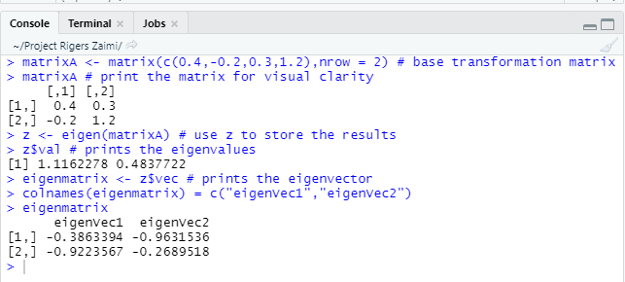

$$X_{k}=c_{1}{\left(1.1162278\right)}^{k}\left[\begin{matrix}-0.3863394 \\ -0.9223567\end{matrix}\right]+c_{2}{\left(0.4837722\right)}^{k}\left[\begin{matrix}-0.9631536 \\ -0.2689518\end{matrix}\right] [8]$$

The function **eigen(matrixA)** calculates both the eigenvalues and vectors and then we store the results in the variable z which will help in later calculations.

What we can expect is an increase in in the total population since λ1 > 1. As k -> ∞ the value of $c_{2}λ_{2}^{k}v_{2}$ will approach 0 and become ever more significant to the final result. This will be shown by graphing later.

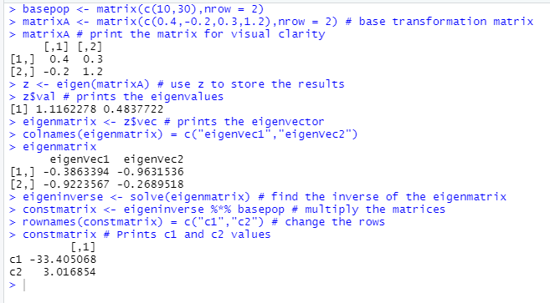

For the given base population matrix**(basepop)** we find the values for the constants c1 and c2. We will use them later to calculate the population throughout a huge time period.

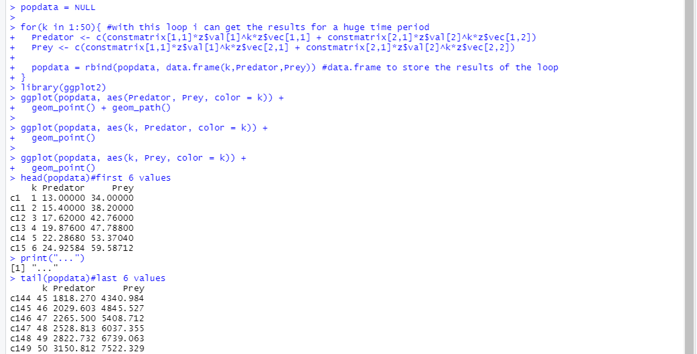

Through a for loop I can store multiple values of the population of the predator and preys**(popdata).** As can be seen the population is increasing with every passing month.

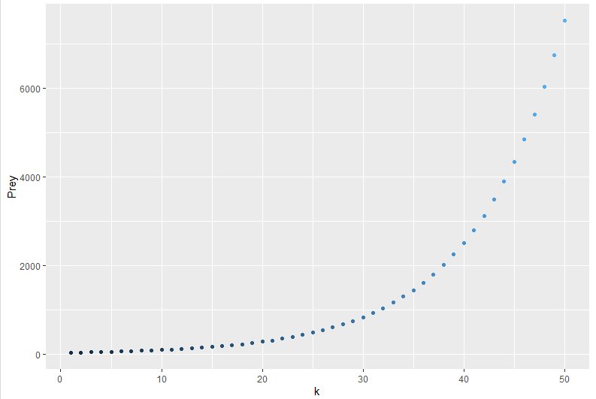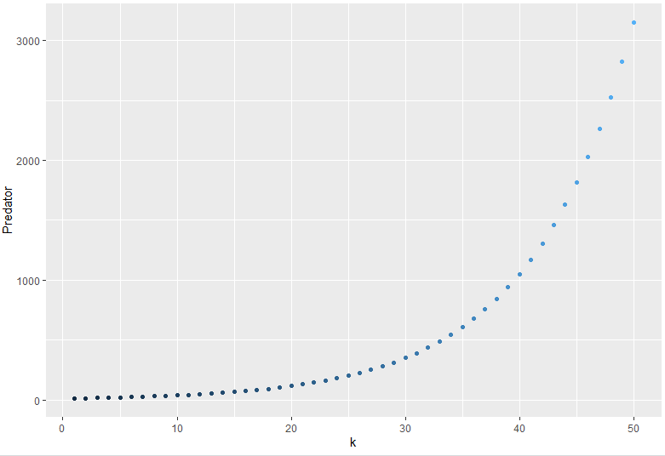

The graphs show the relationship of the population of predators and prey to k(change in time) respectively. They both are growing to ∞ as k -> to ∞.The growth rate grows exponentially through k.

3)Considering eigenvector:

When k becomes sufficiently large, the ratio of $\frac{pred pop.}{prey pop.}$, should be equal to the ration between the vector entries of the eigenvector $v_{1}=\left[\begin{matrix}-0.3863394 \\ -0.9223567\end{matrix}\right]$. This will denote the number of hawks per number of packrats.

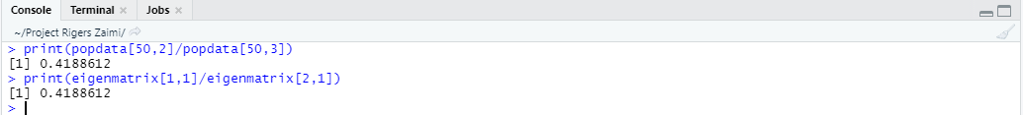

From the results this statement seems to be true. This also tells us that eventually there will be 0.4188612 Hawks for every **1(hundred) packrats**.

* **Considering the effect of** |λ2| < 1

We can remove the second part from the linear combination in **[8]** since for k -> ∞, $c_{2}λ_{2}^{k}v_{2}$ **->** 0 and it won’t affect the results for very large values of k.



The only change I made to the code was removing the part for the calculations necessary to compute $c_{2}λ_{2}^{k}v_{2}$. Below I will show the results before and after this change in the code. As can be seen the first 6 values of the system given by the header function are different. But since the $λ_{2}^{k}$ approaches 0 its contribution to the total population becomes minimal. We can see that for as early as k = 6 the difference becomes negligible.

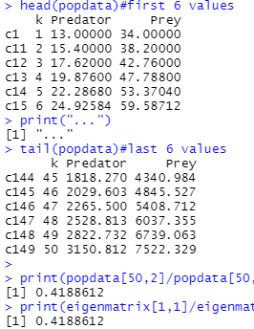 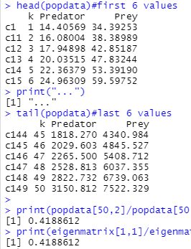

* **Studying the dynamic system for p = 0.5**

Giving the value p = 0.5 the way this system reacts will change drastically. All needed is to change one value in matrixA in rstudio.

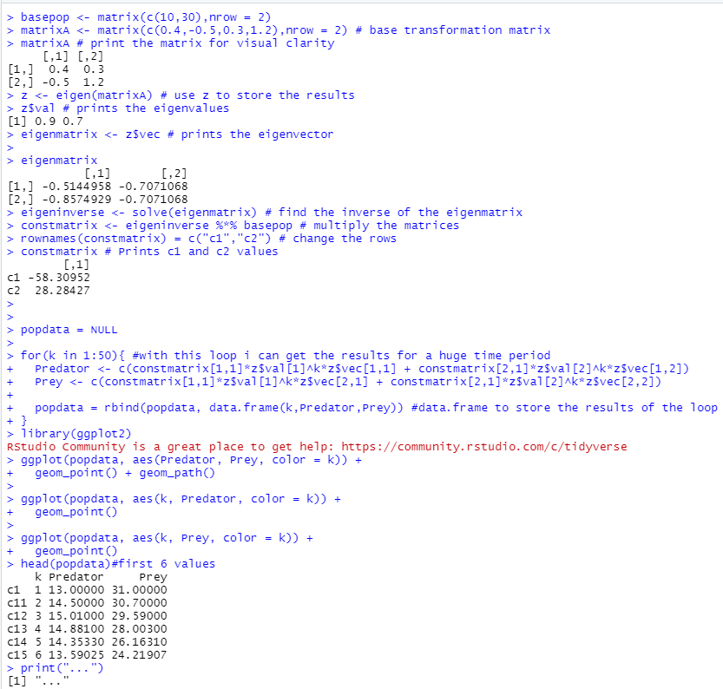

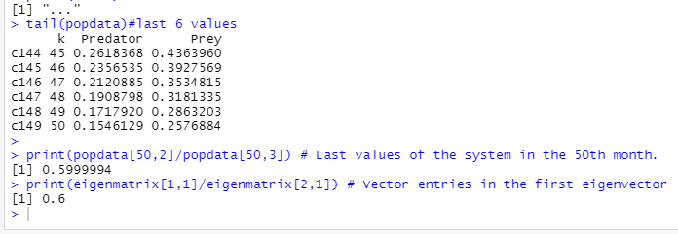

From the data we can see that initially the population of the Hawks is increasing, until the 4th month when it starts decreasing with every passing month. The packrats population on the other hand is ever decreasing from the start. As k -> ∞ both $λ_{1}^{k}$ and $λ_{2}^{k}$ approach 0 and as a result the whole system goes to 0. This is because both of the eigenvalues are smaller than 1 ($λ_{1}=0.9<1 and λ_{2}=0.7<1$). In this case the center is called an attractor and eventually both populations are going to perish. The direction of the greatest attraction belongs to the eigenvector corresponding the eigenvalue with the smaller magnitude. In this case v2 = 0.7 and its corresponding eigenvector is $\left[\begin{matrix}-0.7071068 \\ -0.7071068\end{matrix}\right]=\left[\begin{matrix}1 \\ 1\end{matrix}\right]$.These results are expressed in the graphs below.

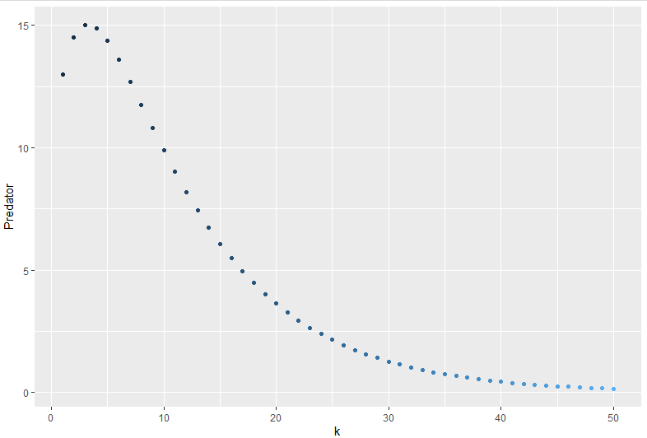 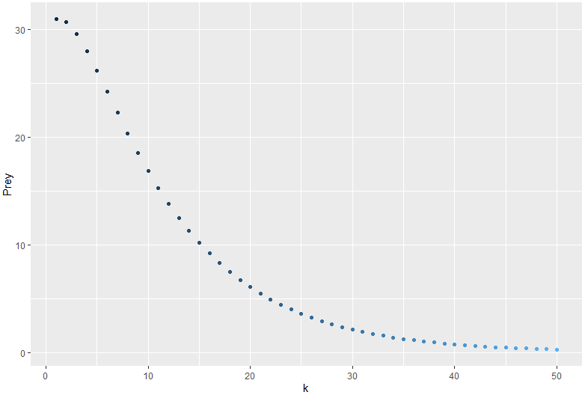

* **Consistent Population–>for p = 0.4**

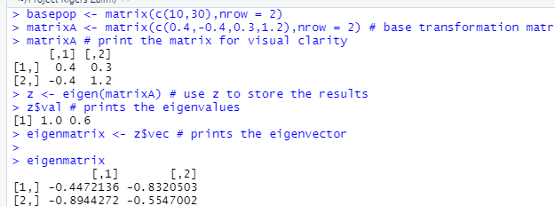

In this case $λ_{1}$**= 1** so that while $λ_{2}< 0$ (its impact becomes negligible as shown In the first example) so that means that eventually both of the populations will reach a consistent population that won’t change while k -> ∞. This is expressed in both the calculations and graph.

